
Trival kompoziti d.o.o.
Bakovnik 3, SI-1241 Kamnik, Slovenija
Telefon: +386 1 8313 341
Telefaks: +386 1 8312 294

ELECTRIC FENCE POLES

They are intended primarily for use in animal breeding, i.e. for erecting a fence for programmed animal grazing. The main advantages include resistance to various influences (rain, sun, salt, chemicals, ...), lightweight, no maintenance and mechanical resistance.

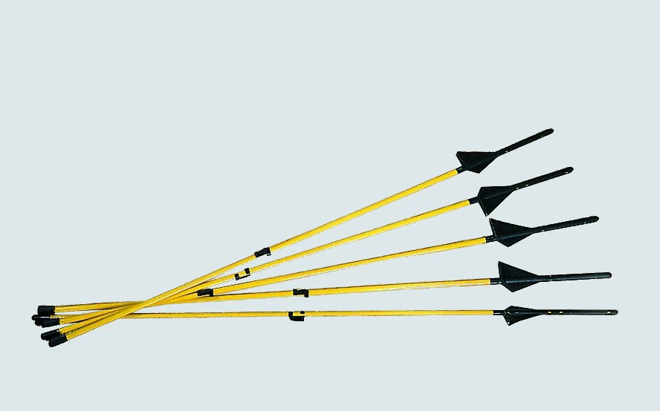

type | lenght (mm)
S01 (10 * 6 mm) | 1.100
S06 (10 * 8 mm) | 1.100
S06 (10 * 8 mm) | 1.400
S06 (10 * 8 mm) | 1.500
S06 (10 * 8 mm) | 1.600
S06 (10*8mm) metalik | 1.100
S06 (10*8mm) metalik | 1.520
Additional slider (isolator) for the column

